

Williams, Brandon
1250 Central Ave #23
Wenatchee, WA 98801

November 12, 2014

Dear Haunted Theatre Volunteer,

Thank you very much for your volunteer work with Haunted Theatre 2014! The help of dedicated and hardworking volunteers like yourself allowed us to raise more than $25,000 to benefit Mission Creek Players and the Eastmont High School Drama Club as well as Riverview Kiwanis and their many worthy projects.

This year, 119 volunteers gave over 3,900 hours of labor to design, build, operate and dismantle this event. Over 2,400 people toured the Haunted Theatre at the armory this year. We could not have brought this popular and enjoyable attraction “back from the dead” to the people of Wenatchee without the hard work and enthusiasm of our volunteers.

Please accept this letter as official acknowledgement of your volunteer time and labor for Mission Creek Players. We are a 501(c) (3) organization.

Williams, Brandon gave 27 hours between the dates of August 23, 2014 and November 1, 2014.

Thanks again for your hard work and support!

Sincerely;
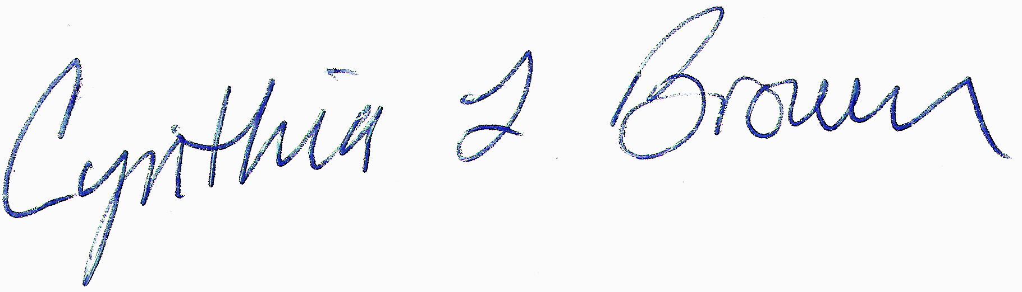
Cynthia Brown
Producer/Director for Haunted Theatre 2014 “Back From The Dead”
(509) 670-8233

